AP CSP Python with CodeX  Mission 11 Assignment |  | Name:
Getting Started

In this project you will create a digital level using the CodeX’s built-in accelerometer and display. During this lesson you will complete all the goals.
Mission 11 : Spirit Level Objectives
Complete Objective 1
Click on accelerometer.
What is the accelerometer?
What are the three directions of the accelerometer?
Create the file. Close the objective panel to see the CodeX in 3D for the 2nd goal.
Complete Objective 2
Read ALL the information, and take notes as needed.
How is a tuple different from a list?
What function reads the accelerometer?
What code will access the raw value of y?
Follow CodeTrek as needed.
Complete Objective 3
Read ALL the information, and take notes as needed.
What does the accelerometer measure?
What does the measurement need to be converted to in this project?
Complete the code. You are going to do some math! Use CodeTrek.
Complete Objective 4
Read ALL the information, and take notes as needed.
What is the size of the CodeX screen?
What does display.fill() do?
What does display.draw_line() do?
What does display.draw_circle() do?
Complete the code. Use CodeTrek if needed.
Complete Objective 5
Read ALL the information, and take notes as needed.
Complete the code. Use CodeTrek as needed. Be careful with the indenting!
What happens when you tilt the CodeX?
Take the quiz. How did you do? Is there a concept you need to review?
Complete Objective 6
Read ALL the information, and take notes as needed.
How do you fix the problem from Obj. 5?
You should be able to do this objective on your own. Use CodeTrek as needed.
Go to the sandbox.
Make this change to your program.
- Create a function for the section of code that converts the accelerometer reading to degrees.
  - The degrees are used in the main program as well, so you may think you need a global variable.
  - Another alternative is for the function to return the degrees.
  - Notice I changed tilt_x to just tilt, so the function can convert for tilt_y as well (abstraction!).
  - The function will look like this:
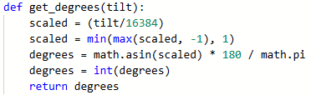
  - And the function call will look like this:
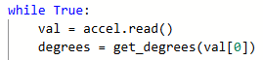
- Optional: Create a function for the background.
- Optional: Add code for a button press to stop the program and clear the screen.
CHALLENGE!
Right now the level is one-dimensional. It only uses the x reading. Add code to your program that will also read the y value, convert the reading to degrees, and use the data when drawing the circle. A 2D spirit level!
Run the program and make sure there are no bugs before submitting. Submit the Spirit_Level program to the teacher.

